**CloudPlatform**



Self Service Desktops

Streaming desktops with Citrix Provisioning Services

  
www.citrix.com

Introduction

This document describes how to stream desktops from PVS with the Citrix Self Service Desktops solution. For more information on the Citrix Self Service Desktops solution see the Installation Guide [1].

Overview

The Citrix Self Service Desktops solution provides a simple way for end users to self-provision desktops. Desktops are hosted in Citrix CloudPlatform; streamed from Provisioning Services; and published to XenDesktop which brokers HDX access to the desktop.

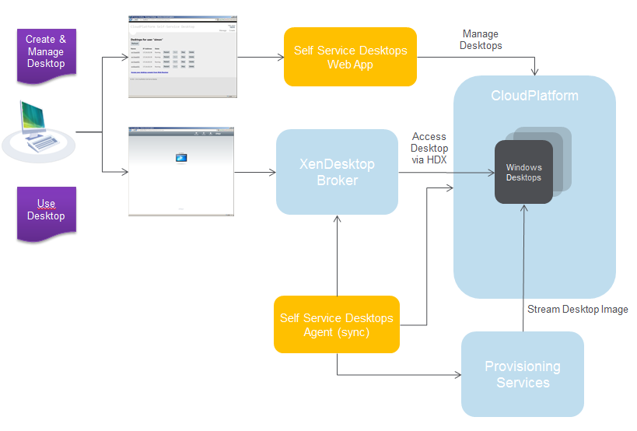

The above diagram illustrates the overall architecture of the solution. Citrix CloudPlatform provides a scalable platform for desktop hosting; Provisioning Services offers a centralized image management facility from which desktops may be streamed into the CloudPlatform environment, and XenDesktop provides a publishing and broking service to provide HDX access to provisioned desktops.

The overall solution is integrated by the Citrix Self Service Desktops solution which comprises two components:

* A simple web application that allows an end user to create and delete desktops on demand, and manage their desktops power states;
* A Self Service Desktops Agent (also known as the sync. script) that integrates the operation of CloudPlatform, XenDesktop and Provisioning Services to provide the overall solution

Further details on the Self Service Desktops solution can be found in [1]

Preparation of Provisioning Services environment

In order to be able to stream desktops into CloudPlatform and manage them with the Citrix Self Service Desktop solution an installation of Citrix Provisioning Services 6.1 is required.

This is just a standard installation of Provisioning Services; please refer to the product documentation [2] to assist you with installation and configuration of Provisioning Services. A very useful video tutorial can also be found at [3] to assist you with a step by step installation guide if you are new to Provisioning Services.

In order for desktops to be streamed into CloudPlatform should ensure that there is direct (no NAT) network connectivity from the CloudPlatform network(s) that you are going to use to host desktops to the Provisioning Services server.

Installation of PVS PowerShell SDK

The Citrix Provisioning Services SDK must be installed on the server that is being used to host the Citrix Self Service Desktop Agent. Reference [4] contains details of how to do this. You need to:

1. Install the Provisioning Services Console from the Provisioning Services DVD onto the server (we won’t be using the console, but as a side effect this installs the PowerShell SDK)
2. Register the PVS snap in DLL using either the 32 bit or 64 bit .NET framework installutil.exe tool depending upon your platform.

If your Windows is 32bits, use this command:

“**C:\Windows\Microsoft.NET\Framework\v2.0.50727\installutil.exe” “C:\Program Files\Citrix\Provisioning Services Console\McliPSSnapIn.dll**”

For 64bits:

“**C:\Windows\Microsoft.NET\Framework64\v2.0.50727\installutil.exe” “C:\Program Files\Citrix\Provisioning Services Console\McliPSSnapIn.dll**”

Desktop Image Preparation

To prepare your desktop image you can leverage existing expertise with Provisioning Services; the video tutorial [3] may also be used as a tutorial for image preparation subject.

Please ensure that before you run the Provisioning Services Imaging Wizard to create a device template:

1. The template machine/device that you are using is domain joined; and
2. The Virtual Desktop Agent (from the XenDesktop 5.6 DVD) is installed on the machine, and configured with the address of the XenDesktop Controller.

Once you have created a vDisk and device template in a device collection on the Provisioning Services server; set the properties of the new vDisk to be Standard Image and Cache on Server. Note that this is the preliminary configuration – a later section of the document will describe how to make use of Provisioning Services client side cache.

Boot ISO Generation

Use the Provisioning Services Boot Device Manager (from the Start Menu on your Provisioning Services server). Specify the address of your Provisioning Services server on page 1 of the wizard, and a boot device of Citrix ISO Image Recorder on the final page, as illustrated below.

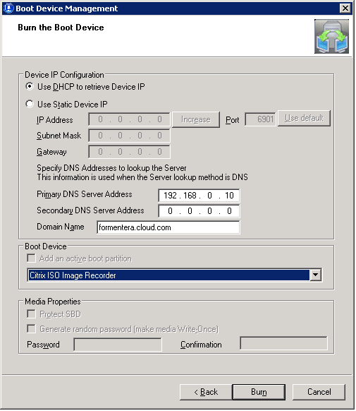

The Provisioning Services Boot Device Manager will write a small ISO file into the file system.

Import this ISO into CloudPlatform, using the Register ISO command, as illustrated below

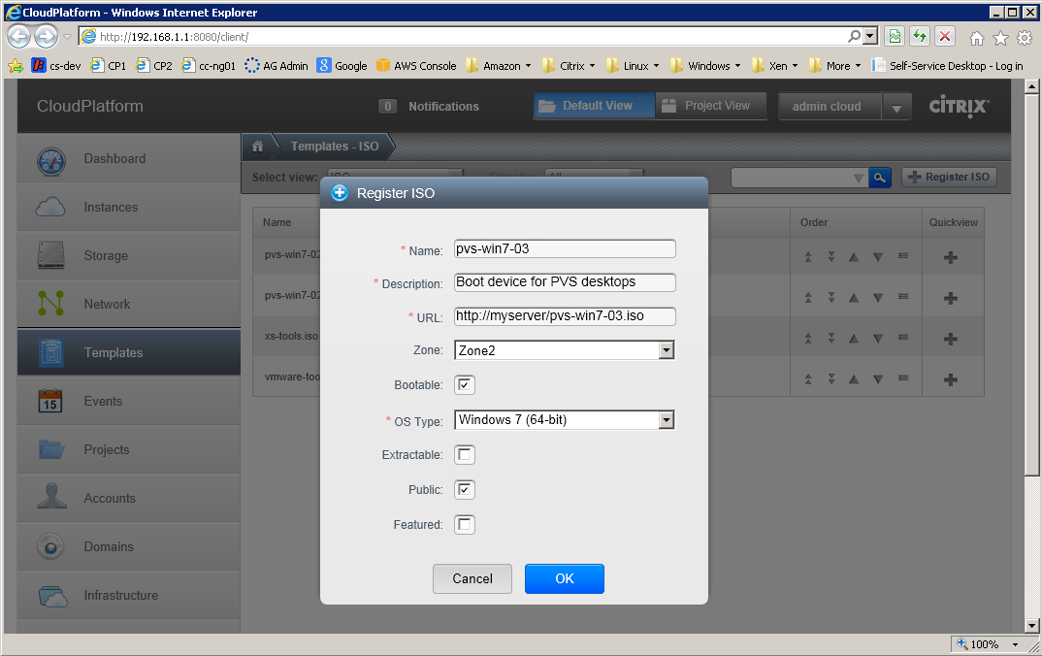

Configure Desktop Offering

In order to publish your new streamed desktop to users of the Self Service Desktop Solution a new desktop offering is required. In the configuration file of the Self Service Desktop add a desktop offering of the form illustrated below:

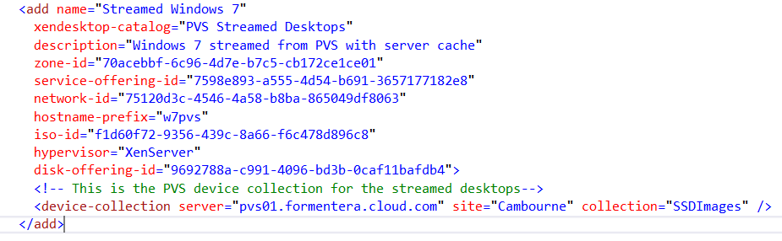

In comparison with a conventional (sysprep) desktop offering, a streamed desktop has no template-id specified, but does require the following additional properties:

1. The id of the ISO (created and registered in the previous step)
2. A disk offering. As currently configured this is not used, but required for an ISO boot in CloudPlatform. A 5GB disk offering is recommended.
3. The type of hypervisor to be used (when booting from ISO, CloudPlatform requires the target hypervisor type to be specified)
4. The Provisioning Services device collection that will be used to host instances of this desktop offering (this should be the device collection into which you imported your desktop template in the previous section)

Verify Streamed Desktop

At this stage the solution is ready to create a streamed desktop. Log into to the web application and create a new streamed desktop. The operation should be very quick compared to the sysprep / Windows Setup equivalent.

After a few minutes you should be able to log onto the XenDesktop Web Interface and log into your new streamed desktop.

The following is a brief troubleshooting guide, if this does not occur:

1. The desktop virtual machine should appear in CloudPlatform with an appropriate name (e.g. w7pvs0001) and boot into the Windows operating system (check with CloudPlatform console and XenCenter)
2. A new device should appear in the specified provisioning services device collection (check with the Provisioning Services console)
3. A new computer with the same name (e.g. w7pvs0001) should appear in Active Directory (check with Users and Computer MMC snap-in on the Domain Controller).
4. A desktop catalog of the specified name (e.g. PVS Streamed Desktops) should appear in XenDesktop with a new desktop in state Ready (it may take a few minutes to move from state Unregistered to Ready) (check with Desktop Studio)

Client side cache support

If you wish to use a client side cache with the Provisioning Services streamed desktop, a template with a disk formatted for use as a Provisioning Services Cache needs to be created.

Create a server cache desktop instance as described above

1. Log into the instance as a domain administrator
2. Start the Disk Management tool (Computer->Manage) and click OK when it asks to initialize the new disk (this is the disk offering that was attached earlier) 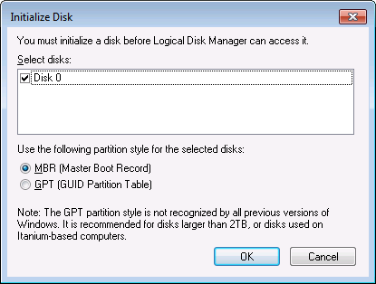
3. Right click on the new disk and select New Simple Volume… to create a disk volume.

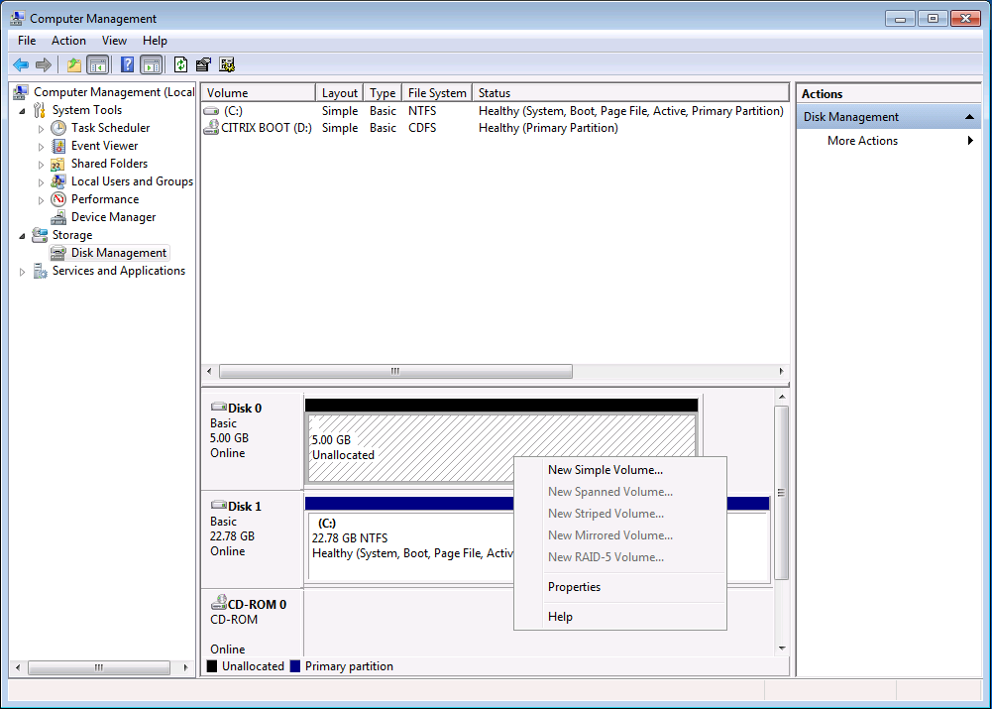

1. Accept the default values, assign the new volume an appropriate label (e.g. PVS Cache) and click OK. Wait for the format process to complete – the new disk should appear in the volume list as illustrated below

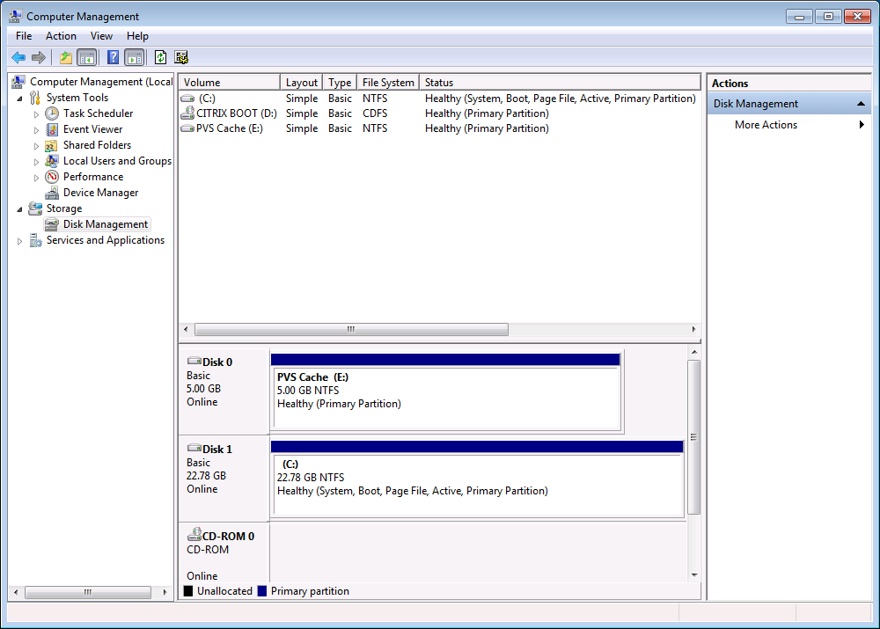

1. Log off the desktop and use the CloudPlatform console to stop the virtual machine. Then select the instance root volume and create a template

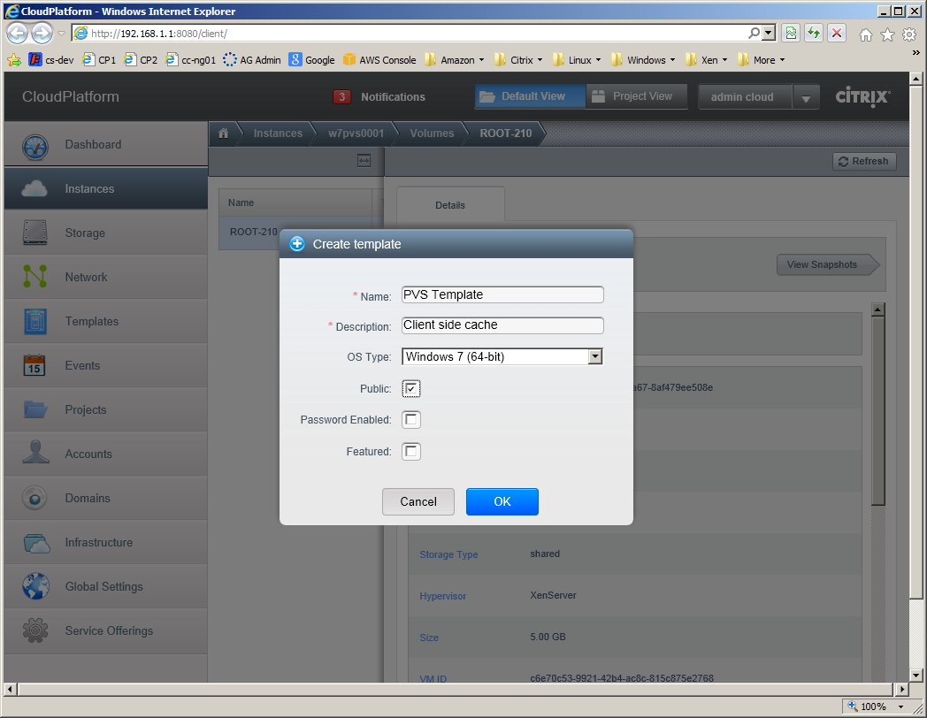

Now there is a template in CloudPlatform with an empty NTFS formatted disk that can be used for a client side cache for Provisioning Services.

To create a desktop offering for this type of machine, follow the pattern illustrated below:

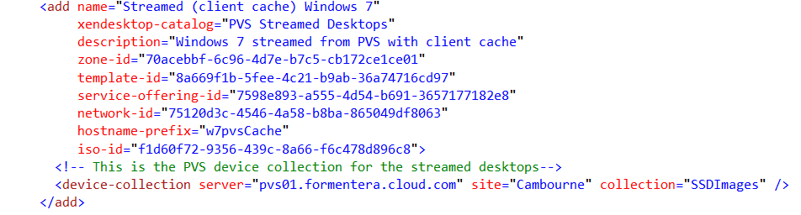

Notice that in this case there is no need to specify either disk-offering or hypervisor; instead a template-id (the template we created above) is specified.

When the Self Service Desktop solution sees a configuration of this pattern, it will create the virtual machine from template in a stopped state, attach the ISO containing the Provisioning Services boot volume and then start the machine to allow it to boot into the streamed desktop from Provisioning Services.

To complete the configuration, log into the Provisioning services console, and change the properties of the vDisk to be Cache on device hard drive to start using a client side cache

If you wish to use client side caching and take advantage of Cloud Platform’s ability to use (hypervisor) local storage to minimize network traffic, then all that is required is to use a disk offering with storage type of Local when setting up the original disk offering.

References

1. Self Service Desktops Installation Guide
2. [Citrix Provisioning Services documentation](http://support.citrix.com/proddocs/topic/provisioning-61/pvs-provisioning-61.html)
3. [Third party guide to installing Provisioning Services](http://www.youtube.com/watch?v=FXf2Fr1zIGk)
4. [Installing PVS PowerShell snap-in](http://blogs.citrix.com/2011/01/11/pvs-powershell-mclipssnapin/)